Formulation of eco-friendly lubricant from non-edible vegetable oils
Juliana Basiron¹, Mohd Fadzli Bin Abdollah^{1,2,*}, Muhammad Ilman Hakimi Chua Abdullah^{1,2},
Hilmi Amiruddin^{1,2}

¹⁾ Fakulti Kejuruteraan Mekanikal, Universiti Teknikal Malaysia Melaka,
Hang Tuah Jaya, 76100 Durian Tunggal, Melaka, Malaysia
²⁾ Centre for Advanced Research on Energy, Universiti Teknikal Malaysia Melaka,
Hang Tuah Jaya, 76100 Durian Tunggal, Melaka, Malaysia

*Corresponding e-mail: mohdfadzli@utem.edu.my

Keywords: Non-edible vegetable oil; eco-friendly lubricant; tribology

ABSTRACT – This study aims to examine the impact of eco-friendly lubricants on friction and wear characteristics. The formulation of eco-friendly lubricant is made by combining SAE 15W40 with non-edible vegetable oils (castor oil and jatropha oil) in a range of 0-100 vol.% using sonication technique. According to engineering standards (ASTM D4172-94), a four-ball tribometer was used to conduct the tribological test. The diameter of the wear scar was measured using a digital microscope. A tribological test reveals that the formulation of eco-friendly lubricant containing 80% SAE 15W40, 10% castor oil, and 10% jatropha oil has the lowest coefficient of friction and wear scar diameter of 0.07560 and 386.3 µm, respectively. Thus, the formulation of eco-friendly lubricants demonstrated superior lubricant performance when compared to pure SAE 15W40, castor oil, and jatropha oil.

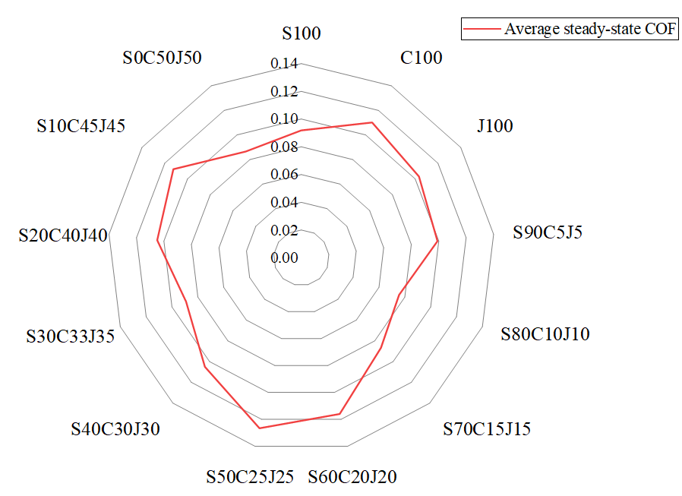
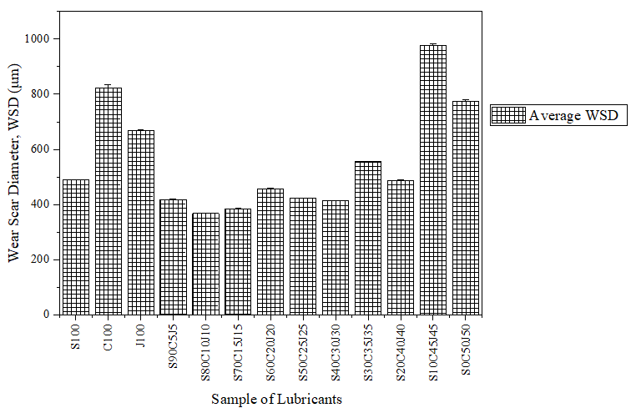
Variation in the coefficient of friction and wear scar diameter of eco-friendly lubricants formulated from mixture of engine oil and non-edible vegetable oils.

